In loving memory of
Jennifer Lucy Bate
11th November 1944 – 25th March 2020

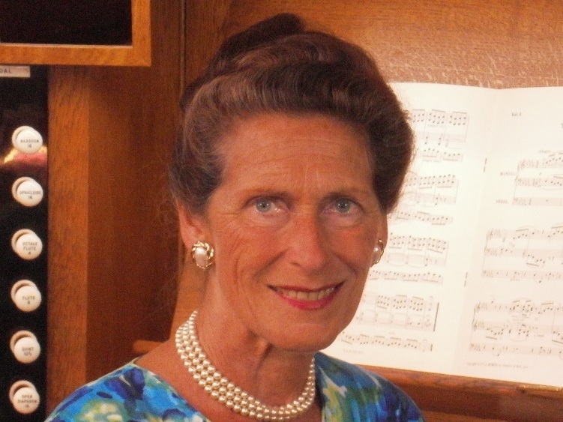

St Marylebone Crematorium, East Finchley
Tuesday 14th April 2020

Service conducted by the Reverend Chris Green
St James’s Parish Church, Muswell Hill

Music on Entry
Opening Theme & Nimrod from Enigma Variations Edward Elgar (arr. Jennifer Bate)

WELCOME and OPENING PRAYER
Reverend Chris Green

HYMN
Guide me, O Thou great Redeemer,
Pilgrim through this barren land;
I am weak, but Thou art mighty,
Hold me with Thy pow'rful hand:
Bread of Heaven, Bread of Heaven,
Feed me till I want no more;
Feed me till I want no more.

Open now the crystal fountain,
Whence the healing stream doth flow;
Let the fire and cloudy pillar
Lead me all my journey through.
Strong Deliverer, strong Deliverer,
Be Thou still my Strength and Shield;
Be Thou still my Strength and Shield.

When I tread the verge of Jordan,
Bid my anxious fears subside;
Death of deaths, and hell’s destruction,
Land me safe on Canaan’s side.
Songs of praises, songs of praises,
I will ever give to Thee;
I will ever give to Thee.

READINGS
Ecclesiastes 3, 1-4; John 14, 1-3; and 2 Corinthians 1, 3-4
HYMN
Tune: Collingwood (H. A. Bate, 1899-1995)
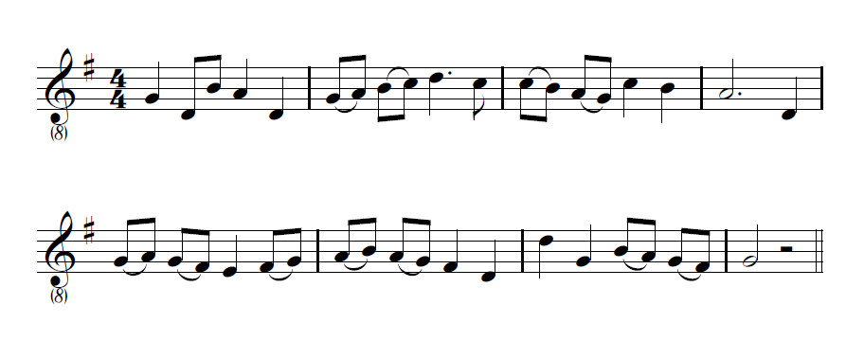
O for a thousand tongues to sing
My dear Redeemer’s praise.
The glories of my God and King,
The triumphs of his grace!

Jesus - the name that charms our fears,
That bids our sorrows cease
‘Tis music to the sinner’s ears
‘Tis life, and health, and peace.

He speaks; and listening to his voice
New life the dead receive,
The mournful broken hearts rejoice,
The humble poor believe.

Hear him, ye deaf; his praise, ye dumb,
Your loosened tongues employ;
Ye blind, behold your Saviour come;
And leap, ye lame, for joy.

My gracious Master and my God,
Assist me to proclaim
And spread through all the earth abroad
The honours of thy name.
PSALM 23
Tune: Crimond (Jessie Irvine, 1836-87)

The Lord’s my shepherd, I’ll not want:
He makes me down to lie
In pastures green; he leadeth me
The quiet waters by.

My soul he doth restore again
And me to walk doth make
Within the paths of righteousness
E’en for his own name’s sake.

Yea, though I walk through death’s dark vale
Yet will I fear no ill:
For thou art with me, and thy rod
And staff me comfort still.

My table thou hast furnishèd
In presence of my foes;
My head thou dost with oil anoint,
And my cup overflows.

Goodness and mercy all my life
Shall surely follow me;
And in God’s house for evermore
My dwelling-place shall be.

EULOGY AND HOMILY
Reverend Chris Green

MUSICAL REFLECTION
Transports de Joie, third movement from Messiaen’s L’Ascension,
recorded in 1982 by Jennifer at Beauvais Cathedral, France

PRAYERS
THE LORD’S PRAYER
Our Father, which art in heaven,
Hallowed be thy name.
Thy kingdom come.
Thy will be done on earth as it is in heaven.
Give us this day our daily bread.
And forgive us our trespasses,
as we forgive them that trespass against us,
And lead us not into temptation,
but deliver us from evil.
For thine is the kingdom, the power and the glory.
For ever and ever.
Amen.

MUSICAL REFLECTION
Ave Maria Franz Schubert (arr. Mark Denza)

HYMN
The day Thou gavest, Lord, is ended,
The darkness falls at Thy behest;
To Thee our morning hymns ascended,
Thy praise shall sanctify our rest.

We thank Thee that Thy church, unsleeping,
While earth rolls onward into light,
Through all the world her watch is keeping,
And rests not now by day or night.

As o’er each continent and island
The dawn leads on another day,
The voice of prayer is never silent,
Nor dies the strain of praise away.

The sun that bids us rest is waking
Our brethren ’neath the western sky,
And hour by hour fresh lips are making
Thy wondrous doings heard on high.

So be it, Lord; Thy throne shall never,
Like earth’s proud empires, pass away:
Thy kingdom stands, and grows forever,
Till all Thy creatures own Thy sway.

COMMITTAL AND BLESSING

Recessional Music

Aria (G. P. Telemann, arr. Jennifer Bate)

Jennifer with her father, 1946
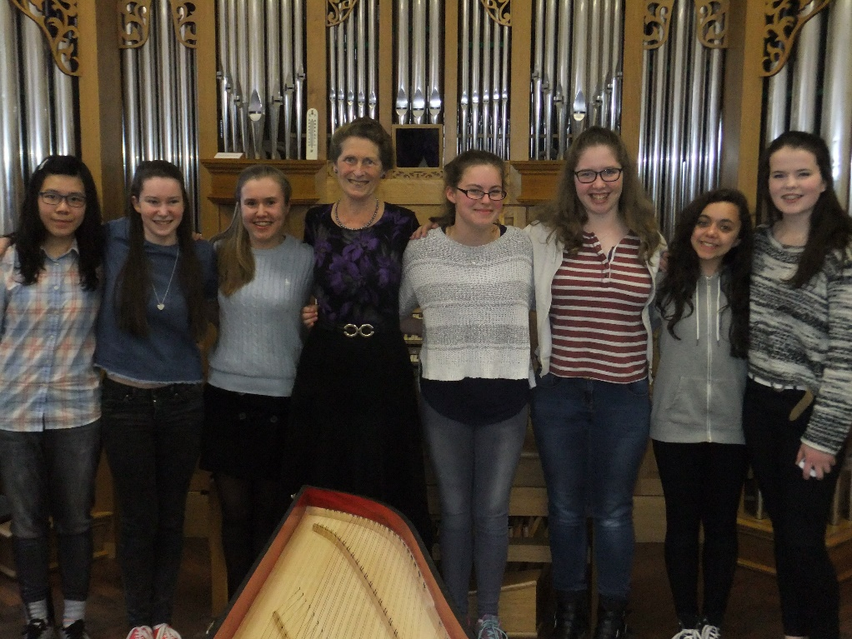
Jennifer with participants at the 12th Jennifer Bate Organ Academy, 2016

